Unsupervised Learning – Clustering

1)kmeans = KMeans(n_clusters = 4, init = 'k-means++',
max_iter = 300, n_init = 10, random_state = 0)
plt.scatter(X_train_std[y_kmeans == 3, 0], X_train_std[y_kmeans == 3, 1],s = 100, c = 'orange')

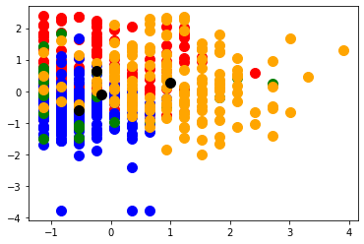

Filename - CellStrat - Clustering - K-means.ipynb

1) If we choose no of clusters k as 2 then distortion increases a lot.
km = KMeans(n_clusters=2,
init='random',
n_init=10,
max_iter=300,
tol=1e-04,
random_state=0)
Distortion: 283.46
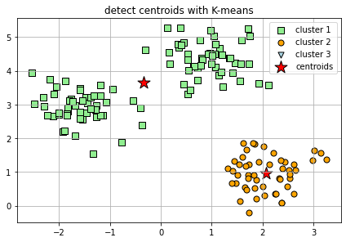

2) If we choose no of clusters k as 6 then distortion decreases a lot.
km = KMeans(n_clusters=6,
init='random',
n_init=10,
max_iter=300,
tol=1e-04,
random_state=0)
Distortion: 47.85

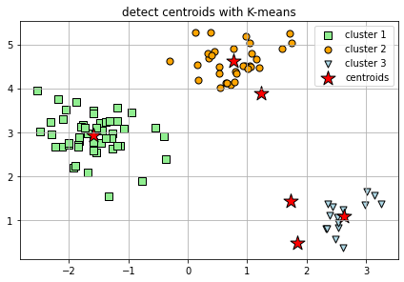

3) X, y = make_blobs(n_samples=15000,
n_features=2,
centers=4,
cluster_std=0.5,
shuffle=True,
random_state=0)
If we change the n_samples from 150 to 15000, no of centers to 4 and keep n_clusters at 3 there would be a huge distortion(sum of square errors).
Distortion: 22550.15
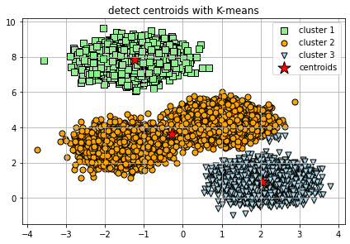
From the elbow method we can see ideal no of clusters for this dataset is 4.
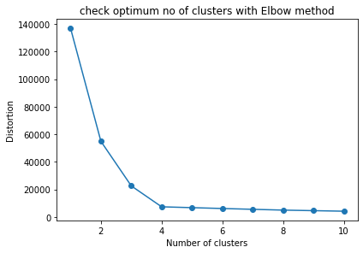
4)X, y = make_blobs(n_samples=15000,
n_features=2,
centers=4,
cluster_std=0.5,
shuffle=True,
random_state=0)
n_clusters=4
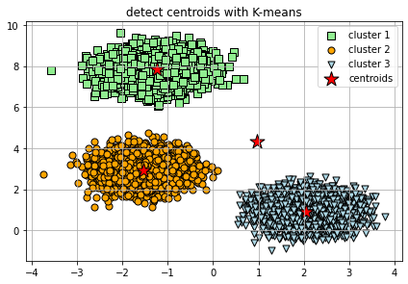
If we change the n_samples from 150 to 15000, no of centers to 4 and keep n_clusters at 4 distortion will be less.
Distortion: 7377.11
from the above elbow method we can see n_clusters=4 is the best solution for this dataset.

